|  |  |  |  |
| --- | --- | --- | --- |
| Лабораториска вежба бр.3 | **Обработка на видеаза адаптивна достава** | | |
| Име и презиме | Индекс |  | Датум |
| Викторија Серафимовска | 201066 |  | 22.12.2022 |

Користејќи го текстот од упатството, креирајте нов документlab3.docx во кој ќе дадете одговор на секое прашање. Документот треба да ги содржи одговорите поткрепени со слики. Датотеката да се спакува и прикачи на линкот за постаување на лабораториската вежба. Сите датотеки кои се креираат во текот на вежбата да се зачуваат во посебни директориуми бидејќи ќе ви бидат потребни и за изработка на следните лаб. вежби.

**Проектната задача не е задолжителна и се изработува самостојно!**

**I Подготовка на работна околина**

1. Инсталирајте ја работната околина GPAC која ги вклучува алатките за прилагодување на видео содржини за адаптивен пренос MP4Box и за прикажување на видеа прилагодени за адаптивен пренос Osmo4. Ивршните датотеки за инсталација преземете ги од https://gpac.wp.mines-telecom.fr/downloads/.

2. Ако до сега немате инсталирано (од претходна лаб вежба), симнете ја најновата верзија на ffmpeg (Ubuntu: <https://tecadmin.net/install-ffmpeg-on-linux/>Windows: https://www.filehorse.com/download-ffmpeg-64/)

3. Симнете произволно видео со траење од неколку минути.

**II Прилагодување на видео за адаптивно доставуање преку DASHсо еден квалитет**

1. Со помош на алатката MP4Box, прилагодете го симнатото видео за адаптивно доставување, така што ќе се доставува само еден квалитет. Траењето на секој сегмент треба да е 2 секунди, меѓутоа, видеото **не треба да се подели во повеќе датотеки**, туку треба да има само една датотека со дефинирани опсези на бајти (се испушта segment-name во командата).Датотеката со мета податоци треба да има различно име од предефинираното и треба да биде сместена на различна локација од предифинираната.

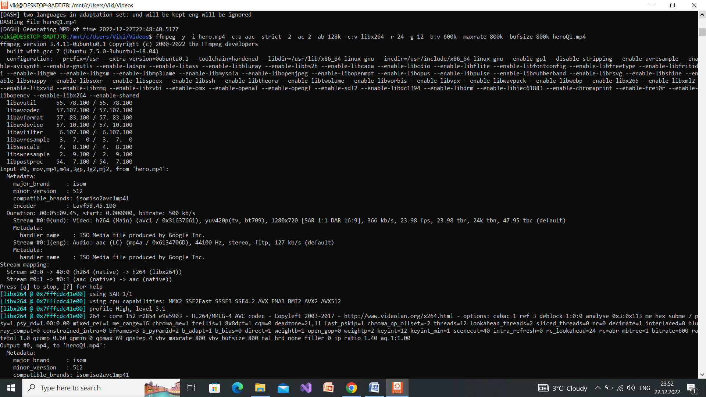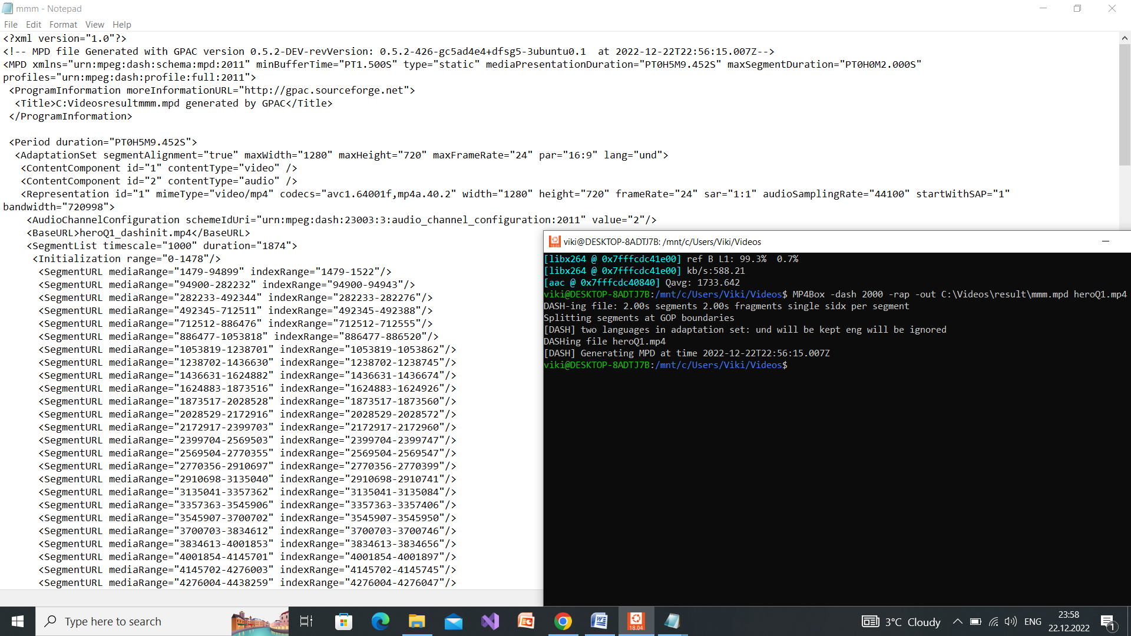

1. Отворете ја алатката Osmo4, изберете ја креираната.mpd датотека и уверете се во исправноста на видеото.
2. Со помош на алатката MP4Box, прилагодете го симнатото видео за адаптивно доставување, така што ќе се доставува само еден квалитет. Траењето на секој сегмент треба да е 2 секунди. Видеото треба да се подели во повеќе датотеки со име како вашиот индекс.Датотеката со мета податоци треба да има различно име од предефинираното и заедно со сегментите да се смести на различна локација од предифинираната.

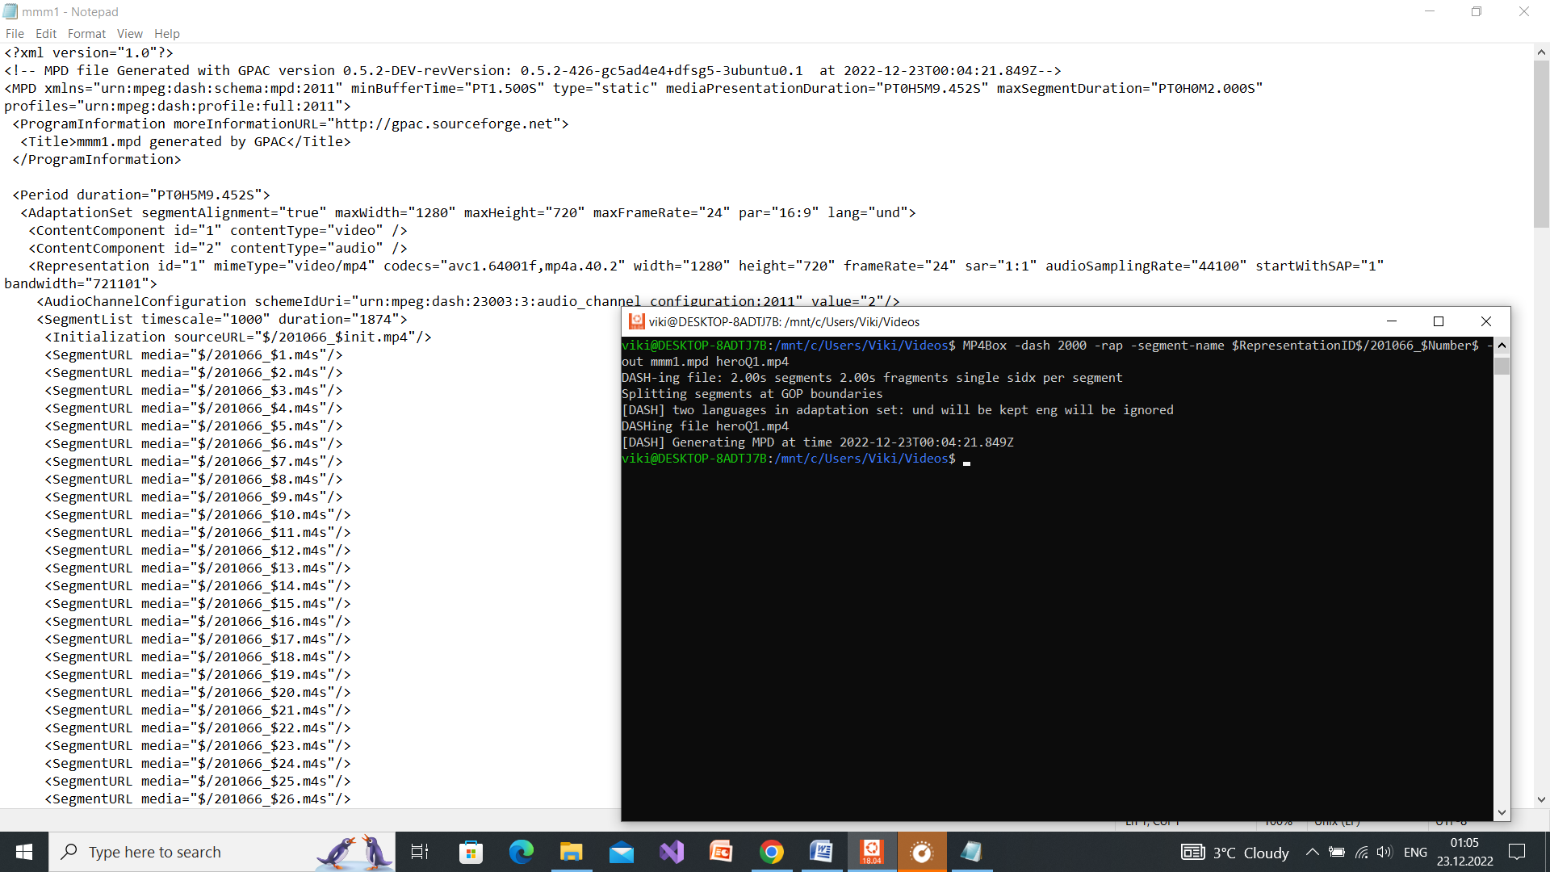

1. Отворете ја алатката Osmo4, изберете ја новата .mpd датотека и уверете се во исправноста на видеото.
2. Колкав број на датотеки се креира? Образложете.

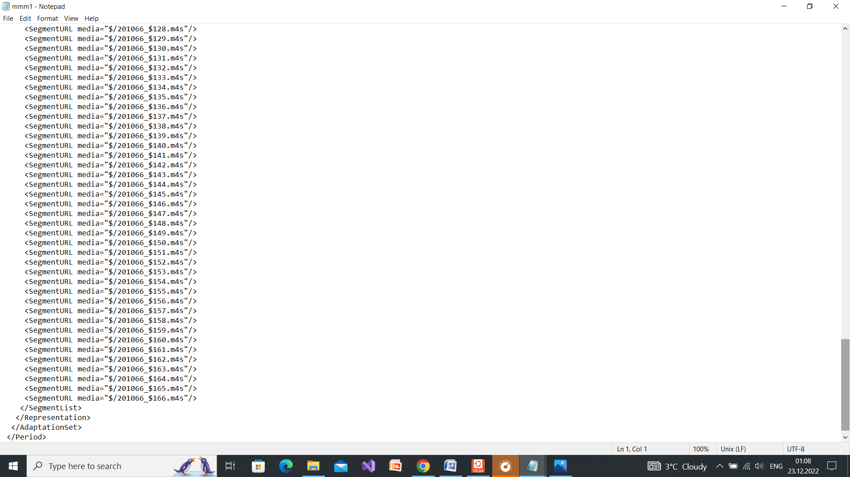

Се креираа 166 датотеки. Видеото heroQ1.mp4 е долго 5минути и 9 секунди има 24 рамки во секунда и gop 12. Секој сегмент трае приближно 2 секунди, но бидејќи ја имаме командата –rap видеото мора да содржи цел gop.

**IIIПрилагодување на видео за адаптивно доставуање преку DASHсо повеќе квалитетина видео и аудио потоци**

1. Со помош на алатката ffprobe испитајте ги основните карактеристики на видеото (прикажете ги во продолжение).

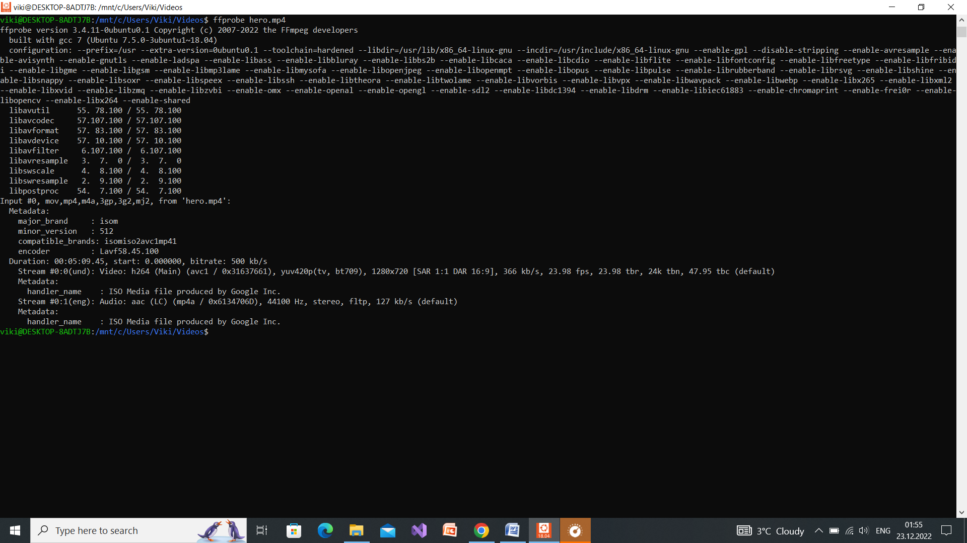

1. Со помош на алатката ffmpeg, креирајте 4 различни верзии на видеото**\*** со квалитетина видео потоцитечии вредности ќе варираат од квалитетот на оригиналното видео до некој минимум кој вие ќе го зададете. Бројот на рамки во секунда да се постави да биде помал од изворната вредност. Да се прилагоди големината на GOP така што ќе биде двојно поголема од бројот на рамки во секунда. Аудио потокот треба да се постави во 4 различни квалитети кои ќе варираат помеѓу максималниот квалитет на изворното аудио (како дел од видеото) и 24kpbs.Наведете ги командите со кои ќе се генерираат различните верзии на видеата.

**\*забелешка**: еден видео (container) е комбинација од видео и аудио поток

- ffmpeg -y -i hero.mp4 -c:a aac -strict -2 -ac 2 -ab 128k - c:v libx264 -r 12 -g 24 -b:v 600k -maxrate 800k -bufsize 800k Q1hero.mp4

- ffmpeg -y -i hero.mp4 -c:a aac -strict -2 -ac 2 -ab 64k - c:v libx264 -r 12 -g 24 -b:v 400k -maxrate 800k -bufsize 800k Q2hero.mp4

- ffmpeg -y -i video.mp4 -c:a aac -strict -2 -ac 2 -ab 32k - c:v libx264 -r 12 -g 24 -b:v 200k -maxrate 800k -bufsize 800k Q3hero.mp4

- ffmpeg -y -i hero.mp4 -c:a aac -strict -2 -ac 2 -ab 24k - c:v libx264 -r 12 -g 24 -b:v 100k -maxrate 800k -bufsize 800k Q4hero.mp4

1. Со помош на алатката MP4Box, прилагодете ги верзиите на видеата со различни квалитети за адаптивно доставување. Секој сегмент треба да содржи 2 GOP. Видеото треба да се подели во повеќе датотеки. Сегментите треба да содржат и видео и аудио потоци комбинирани во една датотека.Mpd датотеката треба да има различно име од предефинираното и заедно со сегментите, да се смести на различна локација од предифинираната.

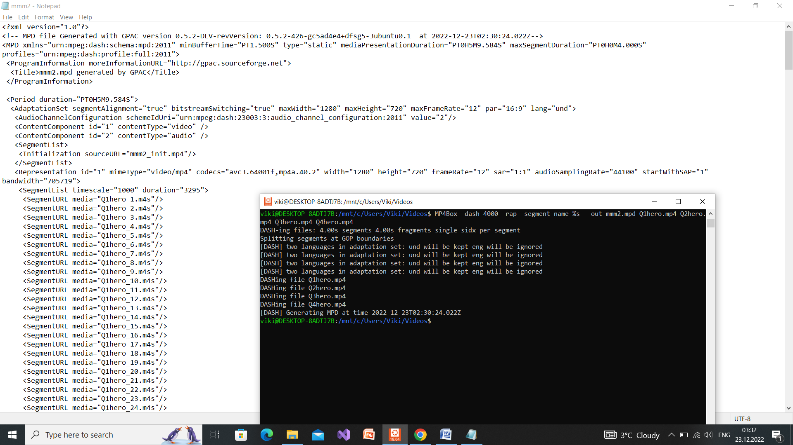

1. Наведете ја листата на датотеки кои се креираат.

<SegmentList timescale="1000" duration="3295">

<SegmentURL media="Q1hero_1.m4s"/>

<SegmentURL media="Q1hero_2.m4s"/>

<SegmentURL media="Q1hero_3.m4s"/>

<SegmentURL media="Q1hero_4.m4s"/>

<SegmentURL media="Q1hero_5.m4s"/>

<SegmentURL media="Q1hero_6.m4s"/>

<SegmentURL media="Q1hero_7.m4s"/>

<SegmentURL media="Q1hero_8.m4s"/>

<SegmentURL media="Q1hero_9.m4s"/>

<SegmentURL media="Q1hero_10.m4s"/>

<SegmentURL media="Q1hero_11.m4s"/>

<SegmentURL media="Q1hero_12.m4s"/>

<SegmentURL media="Q1hero_13.m4s"/>

<SegmentURL media="Q1hero_14.m4s"/>

<SegmentURL media="Q1hero_15.m4s"/>

<SegmentURL media="Q1hero_16.m4s"/>

<SegmentURL media="Q1hero_17.m4s"/>

<SegmentURL media="Q1hero_18.m4s"/>

<SegmentURL media="Q1hero_19.m4s"/>

<SegmentURL media="Q1hero_20.m4s"/>

<SegmentURL media="Q1hero_21.m4s"/>

<SegmentURL media="Q1hero_22.m4s"/>

<SegmentURL media="Q1hero_23.m4s"/>

<SegmentURL media="Q1hero_24.m4s"/>

<SegmentURL media="Q1hero_25.m4s"/>

<SegmentURL media="Q1hero_26.m4s"/>

<SegmentURL media="Q1hero_27.m4s"/>

<SegmentURL media="Q1hero_28.m4s"/>

<SegmentURL media="Q1hero_29.m4s"/>

<SegmentURL media="Q1hero_30.m4s"/>

<SegmentURL media="Q1hero_31.m4s"/>

<SegmentURL media="Q1hero_32.m4s"/>

<SegmentURL media="Q1hero_33.m4s"/>

<SegmentURL media="Q1hero_34.m4s"/>

<SegmentURL media="Q1hero_35.m4s"/>

<SegmentURL media="Q1hero_36.m4s"/>

<SegmentURL media="Q1hero_37.m4s"/>

<SegmentURL media="Q1hero_38.m4s"/>

<SegmentURL media="Q1hero_39.m4s"/>

<SegmentURL media="Q1hero_40.m4s"/>

<SegmentURL media="Q1hero_41.m4s"/>

<SegmentURL media="Q1hero_42.m4s"/>

<SegmentURL media="Q1hero_43.m4s"/>

<SegmentURL media="Q1hero_44.m4s"/>

<SegmentURL media="Q1hero_45.m4s"/>

<SegmentURL media="Q1hero_46.m4s"/>

<SegmentURL media="Q1hero_47.m4s"/>

<SegmentURL media="Q1hero_48.m4s"/>

<SegmentURL media="Q1hero_49.m4s"/>

<SegmentURL media="Q1hero_50.m4s"/>

<SegmentURL media="Q1hero_51.m4s"/>

<SegmentURL media="Q1hero_52.m4s"/>

<SegmentURL media="Q1hero_53.m4s"/>

<SegmentURL media="Q1hero_54.m4s"/>

<SegmentURL media="Q1hero_55.m4s"/>

<SegmentURL media="Q1hero_56.m4s"/>

<SegmentURL media="Q1hero_57.m4s"/>

<SegmentURL media="Q1hero_58.m4s"/>

<SegmentURL media="Q1hero_59.m4s"/>

<SegmentURL media="Q1hero_60.m4s"/>

<SegmentURL media="Q1hero_61.m4s"/>

<SegmentURL media="Q1hero_62.m4s"/>

<SegmentURL media="Q1hero_63.m4s"/>

<SegmentURL media="Q1hero_64.m4s"/>

<SegmentURL media="Q1hero_65.m4s"/>

<SegmentURL media="Q1hero_66.m4s"/>

<SegmentURL media="Q1hero_67.m4s"/>

<SegmentURL media="Q1hero_68.m4s"/>

<SegmentURL media="Q1hero_69.m4s"/>

<SegmentURL media="Q1hero_70.m4s"/>

<SegmentURL media="Q1hero_71.m4s"/>

<SegmentURL media="Q1hero_72.m4s"/>

<SegmentURL media="Q1hero_73.m4s"/>

<SegmentURL media="Q1hero_74.m4s"/>

<SegmentURL media="Q1hero_75.m4s"/>

<SegmentURL media="Q1hero_76.m4s"/>

<SegmentURL media="Q1hero_77.m4s"/>

<SegmentURL media="Q1hero_78.m4s"/>

<SegmentURL media="Q1hero_79.m4s"/>

<SegmentURL media="Q1hero_80.m4s"/>

<SegmentURL media="Q1hero_81.m4s"/>

<SegmentURL media="Q1hero_82.m4s"/>

<SegmentURL media="Q1hero_83.m4s"/>

<SegmentURL media="Q1hero_84.m4s"/>

<SegmentURL media="Q1hero_85.m4s"/>

<SegmentURL media="Q1hero_86.m4s"/>

<SegmentURL media="Q1hero_87.m4s"/>

<SegmentURL media="Q1hero_88.m4s"/>

<SegmentURL media="Q1hero_89.m4s"/>

<SegmentURL media="Q1hero_90.m4s"/>

<SegmentURL media="Q1hero_91.m4s"/>

<SegmentURL media="Q1hero_92.m4s"/>

<SegmentURL media="Q1hero_93.m4s"/>

<SegmentURL media="Q1hero_94.m4s"/>

</SegmentList>

</Representation>

<Representation id="2" mimeType="video/mp4" codecs="avc3.64001f,mp4a.40.2" width="1280" height="720" frameRate="12" sar="1:1" audioSamplingRate="44100" startWithSAP="1" bandwidth="455790">

<SegmentList timescale="1000" duration="3295">

<SegmentURL media="Q2hero_1.m4s"/>

<SegmentURL media="Q2hero_2.m4s"/>

<SegmentURL media="Q2hero_3.m4s"/>

<SegmentURL media="Q2hero_4.m4s"/>

<SegmentURL media="Q2hero_5.m4s"/>

<SegmentURL media="Q2hero_6.m4s"/>

<SegmentURL media="Q2hero_7.m4s"/>

<SegmentURL media="Q2hero_8.m4s"/>

<SegmentURL media="Q2hero_9.m4s"/>

<SegmentURL media="Q2hero_10.m4s"/>

<SegmentURL media="Q2hero_11.m4s"/>

<SegmentURL media="Q2hero_12.m4s"/>

<SegmentURL media="Q2hero_13.m4s"/>

<SegmentURL media="Q2hero_14.m4s"/>

<SegmentURL media="Q2hero_15.m4s"/>

<SegmentURL media="Q2hero_16.m4s"/>

<SegmentURL media="Q2hero_17.m4s"/>

<SegmentURL media="Q2hero_18.m4s"/>

<SegmentURL media="Q2hero_19.m4s"/>

<SegmentURL media="Q2hero_20.m4s"/>

<SegmentURL media="Q2hero_21.m4s"/>

<SegmentURL media="Q2hero_22.m4s"/>

<SegmentURL media="Q2hero_23.m4s"/>

<SegmentURL media="Q2hero_24.m4s"/>

<SegmentURL media="Q2hero_25.m4s"/>

<SegmentURL media="Q2hero_26.m4s"/>

<SegmentURL media="Q2hero_27.m4s"/>

<SegmentURL media="Q2hero_28.m4s"/>

<SegmentURL media="Q2hero_29.m4s"/>

<SegmentURL media="Q2hero_30.m4s"/>

<SegmentURL media="Q2hero_31.m4s"/>

<SegmentURL media="Q2hero_32.m4s"/>

<SegmentURL media="Q2hero_33.m4s"/>

<SegmentURL media="Q2hero_34.m4s"/>

<SegmentURL media="Q2hero_35.m4s"/>

<SegmentURL media="Q2hero_36.m4s"/>

<SegmentURL media="Q2hero_37.m4s"/>

<SegmentURL media="Q2hero_38.m4s"/>

<SegmentURL media="Q2hero_39.m4s"/>

<SegmentURL media="Q2hero_40.m4s"/>

<SegmentURL media="Q2hero_41.m4s"/>

<SegmentURL media="Q2hero_42.m4s"/>

<SegmentURL media="Q2hero_43.m4s"/>

<SegmentURL media="Q2hero_44.m4s"/>

<SegmentURL media="Q2hero_45.m4s"/>

<SegmentURL media="Q2hero_46.m4s"/>

<SegmentURL media="Q2hero_47.m4s"/>

<SegmentURL media="Q2hero_48.m4s"/>

<SegmentURL media="Q2hero_49.m4s"/>

<SegmentURL media="Q2hero_50.m4s"/>

<SegmentURL media="Q2hero_51.m4s"/>

<SegmentURL media="Q2hero_52.m4s"/>

<SegmentURL media="Q2hero_53.m4s"/>

<SegmentURL media="Q2hero_54.m4s"/>

<SegmentURL media="Q2hero_55.m4s"/>

<SegmentURL media="Q2hero_56.m4s"/>

<SegmentURL media="Q2hero_57.m4s"/>

<SegmentURL media="Q2hero_58.m4s"/>

<SegmentURL media="Q2hero_59.m4s"/>

<SegmentURL media="Q2hero_60.m4s"/>

<SegmentURL media="Q2hero_61.m4s"/>

<SegmentURL media="Q2hero_62.m4s"/>

<SegmentURL media="Q2hero_63.m4s"/>

<SegmentURL media="Q2hero_64.m4s"/>

<SegmentURL media="Q2hero_65.m4s"/>

<SegmentURL media="Q2hero_66.m4s"/>

<SegmentURL media="Q2hero_67.m4s"/>

<SegmentURL media="Q2hero_68.m4s"/>

<SegmentURL media="Q2hero_69.m4s"/>

<SegmentURL media="Q2hero_70.m4s"/>

<SegmentURL media="Q2hero_71.m4s"/>

<SegmentURL media="Q2hero_72.m4s"/>

<SegmentURL media="Q2hero_73.m4s"/>

<SegmentURL media="Q2hero_74.m4s"/>

<SegmentURL media="Q2hero_75.m4s"/>

<SegmentURL media="Q2hero_76.m4s"/>

<SegmentURL media="Q2hero_77.m4s"/>

<SegmentURL media="Q2hero_78.m4s"/>

<SegmentURL media="Q2hero_79.m4s"/>

<SegmentURL media="Q2hero_80.m4s"/>

<SegmentURL media="Q2hero_81.m4s"/>

<SegmentURL media="Q2hero_82.m4s"/>

<SegmentURL media="Q2hero_83.m4s"/>

<SegmentURL media="Q2hero_84.m4s"/>

<SegmentURL media="Q2hero_85.m4s"/>

<SegmentURL media="Q2hero_86.m4s"/>

<SegmentURL media="Q2hero_87.m4s"/>

<SegmentURL media="Q2hero_88.m4s"/>

<SegmentURL media="Q2hero_89.m4s"/>

<SegmentURL media="Q2hero_90.m4s"/>

<SegmentURL media="Q2hero_91.m4s"/>

<SegmentURL media="Q2hero_92.m4s"/>

<SegmentURL media="Q2hero_93.m4s"/>

<SegmentURL media="Q2hero_94.m4s"/>

</SegmentList>

</Representation>

<Representation id="3" mimeType="video/mp4" codecs="avc3.64001f,mp4a.40.2" width="1280" height="720" frameRate="12" sar="1:1" audioSamplingRate="44100" startWithSAP="1" bandwidth="229434">

<SegmentList timescale="1000" duration="3295">

<SegmentURL media="Q3hero_1.m4s"/>

<SegmentURL media="Q3hero_2.m4s"/>

<SegmentURL media="Q3hero_3.m4s"/>

<SegmentURL media="Q3hero_4.m4s"/>

<SegmentURL media="Q3hero_5.m4s"/>

<SegmentURL media="Q3hero_6.m4s"/>

<SegmentURL media="Q3hero_7.m4s"/>

<SegmentURL media="Q3hero_8.m4s"/>

<SegmentURL media="Q3hero_9.m4s"/>

<SegmentURL media="Q3hero_10.m4s"/>

<SegmentURL media="Q3hero_11.m4s"/>

<SegmentURL media="Q3hero_12.m4s"/>

<SegmentURL media="Q3hero_13.m4s"/>

<SegmentURL media="Q3hero_14.m4s"/>

<SegmentURL media="Q3hero_15.m4s"/>

<SegmentURL media="Q3hero_16.m4s"/>

<SegmentURL media="Q3hero_17.m4s"/>

<SegmentURL media="Q3hero_18.m4s"/>

<SegmentURL media="Q3hero_19.m4s"/>

<SegmentURL media="Q3hero_20.m4s"/>

<SegmentURL media="Q3hero_21.m4s"/>

<SegmentURL media="Q3hero_22.m4s"/>

<SegmentURL media="Q3hero_23.m4s"/>

<SegmentURL media="Q3hero_24.m4s"/>

<SegmentURL media="Q3hero_25.m4s"/>

<SegmentURL media="Q3hero_26.m4s"/>

<SegmentURL media="Q3hero_27.m4s"/>

<SegmentURL media="Q3hero_28.m4s"/>

<SegmentURL media="Q3hero_29.m4s"/>

<SegmentURL media="Q3hero_30.m4s"/>

<SegmentURL media="Q3hero_31.m4s"/>

<SegmentURL media="Q3hero_32.m4s"/>

<SegmentURL media="Q3hero_33.m4s"/>

<SegmentURL media="Q3hero_34.m4s"/>

<SegmentURL media="Q3hero_35.m4s"/>

<SegmentURL media="Q3hero_36.m4s"/>

<SegmentURL media="Q3hero_37.m4s"/>

<SegmentURL media="Q3hero_38.m4s"/>

<SegmentURL media="Q3hero_39.m4s"/>

<SegmentURL media="Q3hero_40.m4s"/>

<SegmentURL media="Q3hero_41.m4s"/>

<SegmentURL media="Q3hero_42.m4s"/>

<SegmentURL media="Q3hero_43.m4s"/>

<SegmentURL media="Q3hero_44.m4s"/>

<SegmentURL media="Q3hero_45.m4s"/>

<SegmentURL media="Q3hero_46.m4s"/>

<SegmentURL media="Q3hero_47.m4s"/>

<SegmentURL media="Q3hero_48.m4s"/>

<SegmentURL media="Q3hero_49.m4s"/>

<SegmentURL media="Q3hero_50.m4s"/>

<SegmentURL media="Q3hero_51.m4s"/>

<SegmentURL media="Q3hero_52.m4s"/>

<SegmentURL media="Q3hero_53.m4s"/>

<SegmentURL media="Q3hero_54.m4s"/>

<SegmentURL media="Q3hero_55.m4s"/>

<SegmentURL media="Q3hero_56.m4s"/>

<SegmentURL media="Q3hero_57.m4s"/>

<SegmentURL media="Q3hero_58.m4s"/>

<SegmentURL media="Q3hero_59.m4s"/>

<SegmentURL media="Q3hero_60.m4s"/>

<SegmentURL media="Q3hero_61.m4s"/>

<SegmentURL media="Q3hero_62.m4s"/>

<SegmentURL media="Q3hero_63.m4s"/>

<SegmentURL media="Q3hero_64.m4s"/>

<SegmentURL media="Q3hero_65.m4s"/>

<SegmentURL media="Q3hero_66.m4s"/>

<SegmentURL media="Q3hero_67.m4s"/>

<SegmentURL media="Q3hero_68.m4s"/>

<SegmentURL media="Q3hero_69.m4s"/>

<SegmentURL media="Q3hero_70.m4s"/>

<SegmentURL media="Q3hero_71.m4s"/>

<SegmentURL media="Q3hero_72.m4s"/>

<SegmentURL media="Q3hero_73.m4s"/>

<SegmentURL media="Q3hero_74.m4s"/>

<SegmentURL media="Q3hero_75.m4s"/>

<SegmentURL media="Q3hero_76.m4s"/>

<SegmentURL media="Q3hero_77.m4s"/>

<SegmentURL media="Q3hero_78.m4s"/>

<SegmentURL media="Q3hero_79.m4s"/>

<SegmentURL media="Q3hero_80.m4s"/>

<SegmentURL media="Q3hero_81.m4s"/>

<SegmentURL media="Q3hero_82.m4s"/>

<SegmentURL media="Q3hero_83.m4s"/>

<SegmentURL media="Q3hero_84.m4s"/>

<SegmentURL media="Q3hero_85.m4s"/>

<SegmentURL media="Q3hero_86.m4s"/>

<SegmentURL media="Q3hero_87.m4s"/>

<SegmentURL media="Q3hero_88.m4s"/>

<SegmentURL media="Q3hero_89.m4s"/>

<SegmentURL media="Q3hero_90.m4s"/>

<SegmentURL media="Q3hero_91.m4s"/>

<SegmentURL media="Q3hero_92.m4s"/>

<SegmentURL media="Q3hero_93.m4s"/>

<SegmentURL media="Q3hero_94.m4s"/>

</SegmentList>

</Representation>

<Representation id="4" mimeType="video/mp4" codecs="avc3.64001f,mp4a.40.2" width="1280" height="720" frameRate="12" sar="1:1" audioSamplingRate="44100" startWithSAP="1" bandwidth="123733">

<SegmentList timescale="1000" duration="3295">

<SegmentURL media="Q4hero_1.m4s"/>

<SegmentURL media="Q4hero_2.m4s"/>

<SegmentURL media="Q4hero_3.m4s"/>

<SegmentURL media="Q4hero_4.m4s"/>

<SegmentURL media="Q4hero_5.m4s"/>

<SegmentURL media="Q4hero_6.m4s"/>

<SegmentURL media="Q4hero_7.m4s"/>

<SegmentURL media="Q4hero_8.m4s"/>

<SegmentURL media="Q4hero_9.m4s"/>

<SegmentURL media="Q4hero_10.m4s"/>

<SegmentURL media="Q4hero_11.m4s"/>

<SegmentURL media="Q4hero_12.m4s"/>

<SegmentURL media="Q4hero_13.m4s"/>

<SegmentURL media="Q4hero_14.m4s"/>

<SegmentURL media="Q4hero_15.m4s"/>

<SegmentURL media="Q4hero_16.m4s"/>

<SegmentURL media="Q4hero_17.m4s"/>

<SegmentURL media="Q4hero_18.m4s"/>

<SegmentURL media="Q4hero_19.m4s"/>

<SegmentURL media="Q4hero_20.m4s"/>

<SegmentURL media="Q4hero_21.m4s"/>

<SegmentURL media="Q4hero_22.m4s"/>

<SegmentURL media="Q4hero_23.m4s"/>

<SegmentURL media="Q4hero_24.m4s"/>

<SegmentURL media="Q4hero_25.m4s"/>

<SegmentURL media="Q4hero_26.m4s"/>

<SegmentURL media="Q4hero_27.m4s"/>

<SegmentURL media="Q4hero_28.m4s"/>

<SegmentURL media="Q4hero_29.m4s"/>

<SegmentURL media="Q4hero_30.m4s"/>

<SegmentURL media="Q4hero_31.m4s"/>

<SegmentURL media="Q4hero_32.m4s"/>

<SegmentURL media="Q4hero_33.m4s"/>

<SegmentURL media="Q4hero_34.m4s"/>

<SegmentURL media="Q4hero_35.m4s"/>

<SegmentURL media="Q4hero_36.m4s"/>

<SegmentURL media="Q4hero_37.m4s"/>

<SegmentURL media="Q4hero_38.m4s"/>

<SegmentURL media="Q4hero_39.m4s"/>

<SegmentURL media="Q4hero_40.m4s"/>

<SegmentURL media="Q4hero_41.m4s"/>

<SegmentURL media="Q4hero_42.m4s"/>

<SegmentURL media="Q4hero_43.m4s"/>

<SegmentURL media="Q4hero_44.m4s"/>

<SegmentURL media="Q4hero_45.m4s"/>

<SegmentURL media="Q4hero_46.m4s"/>

<SegmentURL media="Q4hero_47.m4s"/>

<SegmentURL media="Q4hero_48.m4s"/>

<SegmentURL media="Q4hero_49.m4s"/>

<SegmentURL media="Q4hero_50.m4s"/>

<SegmentURL media="Q4hero_51.m4s"/>

<SegmentURL media="Q4hero_52.m4s"/>

<SegmentURL media="Q4hero_53.m4s"/>

<SegmentURL media="Q4hero_54.m4s"/>

<SegmentURL media="Q4hero_55.m4s"/>

<SegmentURL media="Q4hero_56.m4s"/>

<SegmentURL media="Q4hero_57.m4s"/>

<SegmentURL media="Q4hero_58.m4s"/>

<SegmentURL media="Q4hero_59.m4s"/>

<SegmentURL media="Q4hero_60.m4s"/>

<SegmentURL media="Q4hero_61.m4s"/>

<SegmentURL media="Q4hero_62.m4s"/>

<SegmentURL media="Q4hero_63.m4s"/>

<SegmentURL media="Q4hero_64.m4s"/>

<SegmentURL media="Q4hero_65.m4s"/>

<SegmentURL media="Q4hero_66.m4s"/>

<SegmentURL media="Q4hero_67.m4s"/>

<SegmentURL media="Q4hero_68.m4s"/>

<SegmentURL media="Q4hero_69.m4s"/>

<SegmentURL media="Q4hero_70.m4s"/>

<SegmentURL media="Q4hero_71.m4s"/>

<SegmentURL media="Q4hero_72.m4s"/>

<SegmentURL media="Q4hero_73.m4s"/>

<SegmentURL media="Q4hero_74.m4s"/>

<SegmentURL media="Q4hero_75.m4s"/>

<SegmentURL media="Q4hero_76.m4s"/>

<SegmentURL media="Q4hero_77.m4s"/>

<SegmentURL media="Q4hero_78.m4s"/>

<SegmentURL media="Q4hero_79.m4s"/>

<SegmentURL media="Q4hero_80.m4s"/>

<SegmentURL media="Q4hero_81.m4s"/>

<SegmentURL media="Q4hero_82.m4s"/>

<SegmentURL media="Q4hero_83.m4s"/>

<SegmentURL media="Q4hero_84.m4s"/>

<SegmentURL media="Q4hero_85.m4s"/>

<SegmentURL media="Q4hero_86.m4s"/>

<SegmentURL media="Q4hero_87.m4s"/>

<SegmentURL media="Q4hero_88.m4s"/>

<SegmentURL media="Q4hero_89.m4s"/>

<SegmentURL media="Q4hero_90.m4s"/>

<SegmentURL media="Q4hero_91.m4s"/>

<SegmentURL media="Q4hero_92.m4s"/>

<SegmentURL media="Q4hero_93.m4s"/>

<SegmentURL media="Q4hero_94.m4s"/>

</SegmentList>

1. Анализирајте ја содржината на mpd датотеката. Колку адаптациски множества има? Колку репрезентации има секое адаптациско множество? Која е содржината на секоја репрезентација?

-Има 1 адаптациско множество видеото и аудиото се мултиплексирани. Адаптациското множество има 4 репрезентации, секоја од нив е комбинација од видео и аудио.

1. Отворете ја алатката Osmo4, изберете ја новата mpd датотека. Уверете се во исправноста на видеото.Менувајте го квалитетот на сегментот кој се прикажува со користење на скратениците CTRL+H (higher quality) и CTRL+L (lower quality).

**IVПрилагодување на видео за адаптивно доставуање преку DASHсо повеќе квалитетина *изолирани* видео и аудио потоци**

1. Со помош на алатката MP4Box и користејќи ги видеата генерирани во III.2, прилагодете го видеот за прикажување на 4 изолирани квалитети на видео потоци (од секое видео се вади соодветниот видео поток) и 2 верзии на аудио потоци со максималниот и минквалитет од видеата генерирани во III.2. Секој сегмент треба да содржи 2 GOP. Видеото треба да се подели во повеќе датотеки. Сегментите **само видео** или **само аудио** потоци. Mpd датотеката треба да има различно име од предефинираното и, заедно со сегментите, да се смести на различна локација од предифинираната.

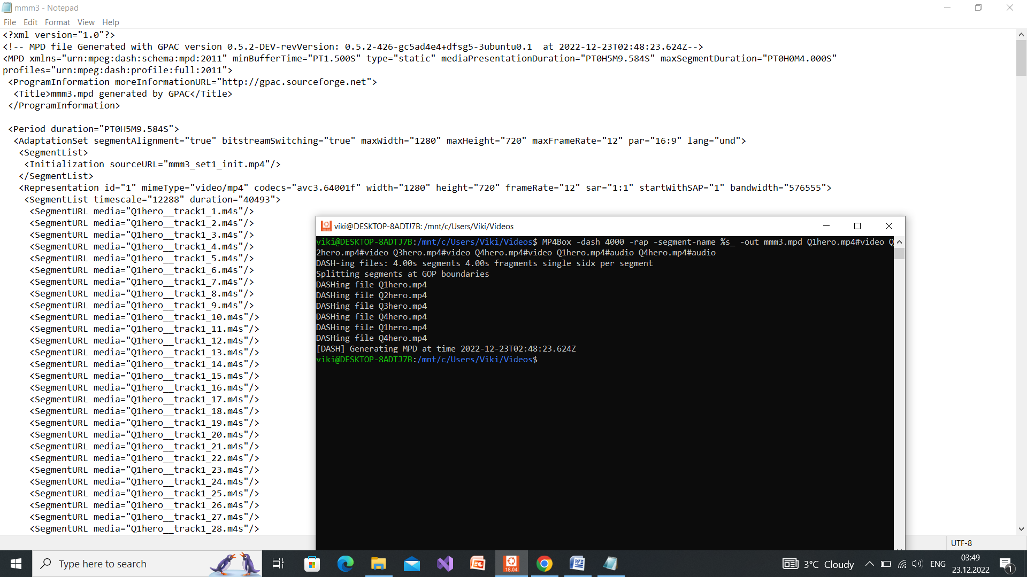

1. Наведете ја листата на датотеки кои се креираат.

<AdaptationSet segmentAlignment="true" bitstreamSwitching="true" maxWidth="1280" maxHeight="720" maxFrameRate="12" par="16:9" lang="und">

<SegmentList>

<Initialization sourceURL="mmm3_set1_init.mp4"/>

</SegmentList>

<Representation id="1" mimeType="video/mp4" codecs="avc3.64001f" width="1280" height="720" frameRate="12" sar="1:1" startWithSAP="1" bandwidth="576555">

<SegmentList timescale="12288" duration="40493">

<SegmentURL media="Q1hero__track1_1.m4s"/>

<SegmentURL media="Q1hero__track1_2.m4s"/>

<SegmentURL media="Q1hero__track1_3.m4s"/>

<SegmentURL media="Q1hero__track1_4.m4s"/>

<SegmentURL media="Q1hero__track1_5.m4s"/>

<SegmentURL media="Q1hero__track1_6.m4s"/>

<SegmentURL media="Q1hero__track1_7.m4s"/>

<SegmentURL media="Q1hero__track1_8.m4s"/>

<SegmentURL media="Q1hero__track1_9.m4s"/>

<SegmentURL media="Q1hero__track1_10.m4s"/>

<SegmentURL media="Q1hero__track1_11.m4s"/>

<SegmentURL media="Q1hero__track1_12.m4s"/>

<SegmentURL media="Q1hero__track1_13.m4s"/>

<SegmentURL media="Q1hero__track1_14.m4s"/>

<SegmentURL media="Q1hero__track1_15.m4s"/>

<SegmentURL media="Q1hero__track1_16.m4s"/>

<SegmentURL media="Q1hero__track1_17.m4s"/>

<SegmentURL media="Q1hero__track1_18.m4s"/>

<SegmentURL media="Q1hero__track1_19.m4s"/>

<SegmentURL media="Q1hero__track1_20.m4s"/>

<SegmentURL media="Q1hero__track1_21.m4s"/>

<SegmentURL media="Q1hero__track1_22.m4s"/>

<SegmentURL media="Q1hero__track1_23.m4s"/>

<SegmentURL media="Q1hero__track1_24.m4s"/>

<SegmentURL media="Q1hero__track1_25.m4s"/>

<SegmentURL media="Q1hero__track1_26.m4s"/>

<SegmentURL media="Q1hero__track1_27.m4s"/>

<SegmentURL media="Q1hero__track1_28.m4s"/>

<SegmentURL media="Q1hero__track1_29.m4s"/>

<SegmentURL media="Q1hero__track1_30.m4s"/>

<SegmentURL media="Q1hero__track1_31.m4s"/>

<SegmentURL media="Q1hero__track1_32.m4s"/>

<SegmentURL media="Q1hero__track1_33.m4s"/>

<SegmentURL media="Q1hero__track1_34.m4s"/>

<SegmentURL media="Q1hero__track1_35.m4s"/>

<SegmentURL media="Q1hero__track1_36.m4s"/>

<SegmentURL media="Q1hero__track1_37.m4s"/>

<SegmentURL media="Q1hero__track1_38.m4s"/>

<SegmentURL media="Q1hero__track1_39.m4s"/>

<SegmentURL media="Q1hero__track1_40.m4s"/>

<SegmentURL media="Q1hero__track1_41.m4s"/>

<SegmentURL media="Q1hero__track1_42.m4s"/>

<SegmentURL media="Q1hero__track1_43.m4s"/>

<SegmentURL media="Q1hero__track1_44.m4s"/>

<SegmentURL media="Q1hero__track1_45.m4s"/>

<SegmentURL media="Q1hero__track1_46.m4s"/>

<SegmentURL media="Q1hero__track1_47.m4s"/>

<SegmentURL media="Q1hero__track1_48.m4s"/>

<SegmentURL media="Q1hero__track1_49.m4s"/>

<SegmentURL media="Q1hero__track1_50.m4s"/>

<SegmentURL media="Q1hero__track1_51.m4s"/>

<SegmentURL media="Q1hero__track1_52.m4s"/>

<SegmentURL media="Q1hero__track1_53.m4s"/>

<SegmentURL media="Q1hero__track1_54.m4s"/>

<SegmentURL media="Q1hero__track1_55.m4s"/>

<SegmentURL media="Q1hero__track1_56.m4s"/>

<SegmentURL media="Q1hero__track1_57.m4s"/>

<SegmentURL media="Q1hero__track1_58.m4s"/>

<SegmentURL media="Q1hero__track1_59.m4s"/>

<SegmentURL media="Q1hero__track1_60.m4s"/>

<SegmentURL media="Q1hero__track1_61.m4s"/>

<SegmentURL media="Q1hero__track1_62.m4s"/>

<SegmentURL media="Q1hero__track1_63.m4s"/>

<SegmentURL media="Q1hero__track1_64.m4s"/>

<SegmentURL media="Q1hero__track1_65.m4s"/>

<SegmentURL media="Q1hero__track1_66.m4s"/>

<SegmentURL media="Q1hero__track1_67.m4s"/>

<SegmentURL media="Q1hero__track1_68.m4s"/>

<SegmentURL media="Q1hero__track1_69.m4s"/>

<SegmentURL media="Q1hero__track1_70.m4s"/>

<SegmentURL media="Q1hero__track1_71.m4s"/>

<SegmentURL media="Q1hero__track1_72.m4s"/>

<SegmentURL media="Q1hero__track1_73.m4s"/>

<SegmentURL media="Q1hero__track1_74.m4s"/>

<SegmentURL media="Q1hero__track1_75.m4s"/>

<SegmentURL media="Q1hero__track1_76.m4s"/>

<SegmentURL media="Q1hero__track1_77.m4s"/>

<SegmentURL media="Q1hero__track1_78.m4s"/>

<SegmentURL media="Q1hero__track1_79.m4s"/>

<SegmentURL media="Q1hero__track1_80.m4s"/>

<SegmentURL media="Q1hero__track1_81.m4s"/>

<SegmentURL media="Q1hero__track1_82.m4s"/>

<SegmentURL media="Q1hero__track1_83.m4s"/>

<SegmentURL media="Q1hero__track1_84.m4s"/>

<SegmentURL media="Q1hero__track1_85.m4s"/>

<SegmentURL media="Q1hero__track1_86.m4s"/>

<SegmentURL media="Q1hero__track1_87.m4s"/>

<SegmentURL media="Q1hero__track1_88.m4s"/>

<SegmentURL media="Q1hero__track1_89.m4s"/>

<SegmentURL media="Q1hero__track1_90.m4s"/>

<SegmentURL media="Q1hero__track1_91.m4s"/>

<SegmentURL media="Q1hero__track1_92.m4s"/>

<SegmentURL media="Q1hero__track1_93.m4s"/>

<SegmentURL media="Q1hero__track1_94.m4s"/>

</SegmentList>

</Representation>

<Representation id="2" mimeType="video/mp4" codecs="avc3.64001f" width="1280" height="720" frameRate="12" sar="1:1" startWithSAP="1" bandwidth="390442">

<SegmentList timescale="12288" duration="40493">

<SegmentURL media="Q2hero__track1_1.m4s"/>

<SegmentURL media="Q2hero__track1_2.m4s"/>

<SegmentURL media="Q2hero__track1_3.m4s"/>

<SegmentURL media="Q2hero__track1_4.m4s"/>

<SegmentURL media="Q2hero__track1_5.m4s"/>

<SegmentURL media="Q2hero__track1_6.m4s"/>

<SegmentURL media="Q2hero__track1_7.m4s"/>

<SegmentURL media="Q2hero__track1_8.m4s"/>

<SegmentURL media="Q2hero__track1_9.m4s"/>

<SegmentURL media="Q2hero__track1_10.m4s"/>

<SegmentURL media="Q2hero__track1_11.m4s"/>

<SegmentURL media="Q2hero__track1_12.m4s"/>

<SegmentURL media="Q2hero__track1_13.m4s"/>

<SegmentURL media="Q2hero__track1_14.m4s"/>

<SegmentURL media="Q2hero__track1_15.m4s"/>

<SegmentURL media="Q2hero__track1_16.m4s"/>

<SegmentURL media="Q2hero__track1_17.m4s"/>

<SegmentURL media="Q2hero__track1_18.m4s"/>

<SegmentURL media="Q2hero__track1_19.m4s"/>

<SegmentURL media="Q2hero__track1_20.m4s"/>

<SegmentURL media="Q2hero__track1_21.m4s"/>

<SegmentURL media="Q2hero__track1_22.m4s"/>

<SegmentURL media="Q2hero__track1_23.m4s"/>

<SegmentURL media="Q2hero__track1_24.m4s"/>

<SegmentURL media="Q2hero__track1_25.m4s"/>

<SegmentURL media="Q2hero__track1_26.m4s"/>

<SegmentURL media="Q2hero__track1_27.m4s"/>

<SegmentURL media="Q2hero__track1_28.m4s"/>

<SegmentURL media="Q2hero__track1_29.m4s"/>

<SegmentURL media="Q2hero__track1_30.m4s"/>

<SegmentURL media="Q2hero__track1_31.m4s"/>

<SegmentURL media="Q2hero__track1_32.m4s"/>

<SegmentURL media="Q2hero__track1_33.m4s"/>

<SegmentURL media="Q2hero__track1_34.m4s"/>

<SegmentURL media="Q2hero__track1_35.m4s"/>

<SegmentURL media="Q2hero__track1_36.m4s"/>

<SegmentURL media="Q2hero__track1_37.m4s"/>

<SegmentURL media="Q2hero__track1_38.m4s"/>

<SegmentURL media="Q2hero__track1_39.m4s"/>

<SegmentURL media="Q2hero__track1_40.m4s"/>

<SegmentURL media="Q2hero__track1_41.m4s"/>

<SegmentURL media="Q2hero__track1_42.m4s"/>

<SegmentURL media="Q2hero__track1_43.m4s"/>

<SegmentURL media="Q2hero__track1_44.m4s"/>

<SegmentURL media="Q2hero__track1_45.m4s"/>

<SegmentURL media="Q2hero__track1_46.m4s"/>

<SegmentURL media="Q2hero__track1_47.m4s"/>

<SegmentURL media="Q2hero__track1_48.m4s"/>

<SegmentURL media="Q2hero__track1_49.m4s"/>

<SegmentURL media="Q2hero__track1_50.m4s"/>

<SegmentURL media="Q2hero__track1_51.m4s"/>

<SegmentURL media="Q2hero__track1_52.m4s"/>

<SegmentURL media="Q2hero__track1_53.m4s"/>

<SegmentURL media="Q2hero__track1_54.m4s"/>

<SegmentURL media="Q2hero__track1_55.m4s"/>

<SegmentURL media="Q2hero__track1_56.m4s"/>

<SegmentURL media="Q2hero__track1_57.m4s"/>

<SegmentURL media="Q2hero__track1_58.m4s"/>

<SegmentURL media="Q2hero__track1_59.m4s"/>

<SegmentURL media="Q2hero__track1_60.m4s"/>

<SegmentURL media="Q2hero__track1_61.m4s"/>

<SegmentURL media="Q2hero__track1_62.m4s"/>

<SegmentURL media="Q2hero__track1_63.m4s"/>

<SegmentURL media="Q2hero__track1_64.m4s"/>

<SegmentURL media="Q2hero__track1_65.m4s"/>

<SegmentURL media="Q2hero__track1_66.m4s"/>

<SegmentURL media="Q2hero__track1_67.m4s"/>

<SegmentURL media="Q2hero__track1_68.m4s"/>

<SegmentURL media="Q2hero__track1_69.m4s"/>

<SegmentURL media="Q2hero__track1_70.m4s"/>

<SegmentURL media="Q2hero__track1_71.m4s"/>

<SegmentURL media="Q2hero__track1_72.m4s"/>

<SegmentURL media="Q2hero__track1_73.m4s"/>

<SegmentURL media="Q2hero__track1_74.m4s"/>

<SegmentURL media="Q2hero__track1_75.m4s"/>

<SegmentURL media="Q2hero__track1_76.m4s"/>

<SegmentURL media="Q2hero__track1_77.m4s"/>

<SegmentURL media="Q2hero__track1_78.m4s"/>

<SegmentURL media="Q2hero__track1_79.m4s"/>

<SegmentURL media="Q2hero__track1_80.m4s"/>

<SegmentURL media="Q2hero__track1_81.m4s"/>

<SegmentURL media="Q2hero__track1_82.m4s"/>

<SegmentURL media="Q2hero__track1_83.m4s"/>

<SegmentURL media="Q2hero__track1_84.m4s"/>

<SegmentURL media="Q2hero__track1_85.m4s"/>

<SegmentURL media="Q2hero__track1_86.m4s"/>

<SegmentURL media="Q2hero__track1_87.m4s"/>

<SegmentURL media="Q2hero__track1_88.m4s"/>

<SegmentURL media="Q2hero__track1_89.m4s"/>

<SegmentURL media="Q2hero__track1_90.m4s"/>

<SegmentURL media="Q2hero__track1_91.m4s"/>

<SegmentURL media="Q2hero__track1_92.m4s"/>

<SegmentURL media="Q2hero__track1_93.m4s"/>

<SegmentURL media="Q2hero__track1_94.m4s"/>

</SegmentList>

</Representation>

<Representation id="3" mimeType="video/mp4" codecs="avc3.64001f" width="1280" height="720" frameRate="12" sar="1:1" startWithSAP="1" bandwidth="196566">

<SegmentList timescale="12288" duration="40493">

<SegmentURL media="Q3hero__track1_1.m4s"/>

<SegmentURL media="Q3hero__track1_2.m4s"/>

<SegmentURL media="Q3hero__track1_3.m4s"/>

<SegmentURL media="Q3hero__track1_4.m4s"/>

<SegmentURL media="Q3hero__track1_5.m4s"/>

<SegmentURL media="Q3hero__track1_6.m4s"/>

<SegmentURL media="Q3hero__track1_7.m4s"/>

<SegmentURL media="Q3hero__track1_8.m4s"/>

<SegmentURL media="Q3hero__track1_9.m4s"/>

<SegmentURL media="Q3hero__track1_10.m4s"/>

<SegmentURL media="Q3hero__track1_11.m4s"/>

<SegmentURL media="Q3hero__track1_12.m4s"/>

<SegmentURL media="Q3hero__track1_13.m4s"/>

<SegmentURL media="Q3hero__track1_14.m4s"/>

<SegmentURL media="Q3hero__track1_15.m4s"/>

<SegmentURL media="Q3hero__track1_16.m4s"/>

<SegmentURL media="Q3hero__track1_17.m4s"/>

<SegmentURL media="Q3hero__track1_18.m4s"/>

<SegmentURL media="Q3hero__track1_19.m4s"/>

<SegmentURL media="Q3hero__track1_20.m4s"/>

<SegmentURL media="Q3hero__track1_21.m4s"/>

<SegmentURL media="Q3hero__track1_22.m4s"/>

<SegmentURL media="Q3hero__track1_23.m4s"/>

<SegmentURL media="Q3hero__track1_24.m4s"/>

<SegmentURL media="Q3hero__track1_25.m4s"/>

<SegmentURL media="Q3hero__track1_26.m4s"/>

<SegmentURL media="Q3hero__track1_27.m4s"/>

<SegmentURL media="Q3hero__track1_28.m4s"/>

<SegmentURL media="Q3hero__track1_29.m4s"/>

<SegmentURL media="Q3hero__track1_30.m4s"/>

<SegmentURL media="Q3hero__track1_31.m4s"/>

<SegmentURL media="Q3hero__track1_32.m4s"/>

<SegmentURL media="Q3hero__track1_33.m4s"/>

<SegmentURL media="Q3hero__track1_34.m4s"/>

<SegmentURL media="Q3hero__track1_35.m4s"/>

<SegmentURL media="Q3hero__track1_36.m4s"/>

<SegmentURL media="Q3hero__track1_37.m4s"/>

<SegmentURL media="Q3hero__track1_38.m4s"/>

<SegmentURL media="Q3hero__track1_39.m4s"/>

<SegmentURL media="Q3hero__track1_40.m4s"/>

<SegmentURL media="Q3hero__track1_41.m4s"/>

<SegmentURL media="Q3hero__track1_42.m4s"/>

<SegmentURL media="Q3hero__track1_43.m4s"/>

<SegmentURL media="Q3hero__track1_44.m4s"/>

<SegmentURL media="Q3hero__track1_45.m4s"/>

<SegmentURL media="Q3hero__track1_46.m4s"/>

<SegmentURL media="Q3hero__track1_47.m4s"/>

<SegmentURL media="Q3hero__track1_48.m4s"/>

<SegmentURL media="Q3hero__track1_49.m4s"/>

<SegmentURL media="Q3hero__track1_50.m4s"/>

<SegmentURL media="Q3hero__track1_51.m4s"/>

<SegmentURL media="Q3hero__track1_52.m4s"/>

<SegmentURL media="Q3hero__track1_53.m4s"/>

<SegmentURL media="Q3hero__track1_54.m4s"/>

<SegmentURL media="Q3hero__track1_55.m4s"/>

<SegmentURL media="Q3hero__track1_56.m4s"/>

<SegmentURL media="Q3hero__track1_57.m4s"/>

<SegmentURL media="Q3hero__track1_58.m4s"/>

<SegmentURL media="Q3hero__track1_59.m4s"/>

<SegmentURL media="Q3hero__track1_60.m4s"/>

<SegmentURL media="Q3hero__track1_61.m4s"/>

<SegmentURL media="Q3hero__track1_62.m4s"/>

<SegmentURL media="Q3hero__track1_63.m4s"/>

<SegmentURL media="Q3hero__track1_64.m4s"/>

<SegmentURL media="Q3hero__track1_65.m4s"/>

<SegmentURL media="Q3hero__track1_66.m4s"/>

<SegmentURL media="Q3hero__track1_67.m4s"/>

<SegmentURL media="Q3hero__track1_68.m4s"/>

<SegmentURL media="Q3hero__track1_69.m4s"/>

<SegmentURL media="Q3hero__track1_70.m4s"/>

<SegmentURL media="Q3hero__track1_71.m4s"/>

<SegmentURL media="Q3hero__track1_72.m4s"/>

<SegmentURL media="Q3hero__track1_73.m4s"/>

<SegmentURL media="Q3hero__track1_74.m4s"/>

<SegmentURL media="Q3hero__track1_75.m4s"/>

<SegmentURL media="Q3hero__track1_76.m4s"/>

<SegmentURL media="Q3hero__track1_77.m4s"/>

<SegmentURL media="Q3hero__track1_78.m4s"/>

<SegmentURL media="Q3hero__track1_79.m4s"/>

<SegmentURL media="Q3hero__track1_80.m4s"/>

<SegmentURL media="Q3hero__track1_81.m4s"/>

<SegmentURL media="Q3hero__track1_82.m4s"/>

<SegmentURL media="Q3hero__track1_83.m4s"/>

<SegmentURL media="Q3hero__track1_84.m4s"/>

<SegmentURL media="Q3hero__track1_85.m4s"/>

<SegmentURL media="Q3hero__track1_86.m4s"/>

<SegmentURL media="Q3hero__track1_87.m4s"/>

<SegmentURL media="Q3hero__track1_88.m4s"/>

<SegmentURL media="Q3hero__track1_89.m4s"/>

<SegmentURL media="Q3hero__track1_90.m4s"/>

<SegmentURL media="Q3hero__track1_91.m4s"/>

<SegmentURL media="Q3hero__track1_92.m4s"/>

<SegmentURL media="Q3hero__track1_93.m4s"/>

<SegmentURL media="Q3hero__track1_94.m4s"/>

</SegmentList>

</Representation>

<Representation id="4" mimeType="video/mp4" codecs="avc3.64001f" width="1280" height="720" frameRate="12" sar="1:1" startWithSAP="1" bandwidth="99149">

<SegmentList timescale="12288" duration="40493">

<SegmentURL media="Q4hero__track1_1.m4s"/>

<SegmentURL media="Q4hero__track1_2.m4s"/>

<SegmentURL media="Q4hero__track1_3.m4s"/>

<SegmentURL media="Q4hero__track1_4.m4s"/>

<SegmentURL media="Q4hero__track1_5.m4s"/>

<SegmentURL media="Q4hero__track1_6.m4s"/>

<SegmentURL media="Q4hero__track1_7.m4s"/>

<SegmentURL media="Q4hero__track1_8.m4s"/>

<SegmentURL media="Q4hero__track1_9.m4s"/>

<SegmentURL media="Q4hero__track1_10.m4s"/>

<SegmentURL media="Q4hero__track1_11.m4s"/>

<SegmentURL media="Q4hero__track1_12.m4s"/>

<SegmentURL media="Q4hero__track1_13.m4s"/>

<SegmentURL media="Q4hero__track1_14.m4s"/>

<SegmentURL media="Q4hero__track1_15.m4s"/>

<SegmentURL media="Q4hero__track1_16.m4s"/>

<SegmentURL media="Q4hero__track1_17.m4s"/>

<SegmentURL media="Q4hero__track1_18.m4s"/>

<SegmentURL media="Q4hero__track1_19.m4s"/>

<SegmentURL media="Q4hero__track1_20.m4s"/>

<SegmentURL media="Q4hero__track1_21.m4s"/>

<SegmentURL media="Q4hero__track1_22.m4s"/>

<SegmentURL media="Q4hero__track1_23.m4s"/>

<SegmentURL media="Q4hero__track1_24.m4s"/>

<SegmentURL media="Q4hero__track1_25.m4s"/>

<SegmentURL media="Q4hero__track1_26.m4s"/>

<SegmentURL media="Q4hero__track1_27.m4s"/>

<SegmentURL media="Q4hero__track1_28.m4s"/>

<SegmentURL media="Q4hero__track1_29.m4s"/>

<SegmentURL media="Q4hero__track1_30.m4s"/>

<SegmentURL media="Q4hero__track1_31.m4s"/>

<SegmentURL media="Q4hero__track1_32.m4s"/>

<SegmentURL media="Q4hero__track1_33.m4s"/>

<SegmentURL media="Q4hero__track1_34.m4s"/>

<SegmentURL media="Q4hero__track1_35.m4s"/>

<SegmentURL media="Q4hero__track1_36.m4s"/>

<SegmentURL media="Q4hero__track1_37.m4s"/>

<SegmentURL media="Q4hero__track1_38.m4s"/>

<SegmentURL media="Q4hero__track1_39.m4s"/>

<SegmentURL media="Q4hero__track1_40.m4s"/>

<SegmentURL media="Q4hero__track1_41.m4s"/>

<SegmentURL media="Q4hero__track1_42.m4s"/>

<SegmentURL media="Q4hero__track1_43.m4s"/>

<SegmentURL media="Q4hero__track1_44.m4s"/>

<SegmentURL media="Q4hero__track1_45.m4s"/>

<SegmentURL media="Q4hero__track1_46.m4s"/>

<SegmentURL media="Q4hero__track1_47.m4s"/>

<SegmentURL media="Q4hero__track1_48.m4s"/>

<SegmentURL media="Q4hero__track1_49.m4s"/>

<SegmentURL media="Q4hero__track1_50.m4s"/>

<SegmentURL media="Q4hero__track1_51.m4s"/>

<SegmentURL media="Q4hero__track1_52.m4s"/>

<SegmentURL media="Q4hero__track1_53.m4s"/>

<SegmentURL media="Q4hero__track1_54.m4s"/>

<SegmentURL media="Q4hero__track1_55.m4s"/>

<SegmentURL media="Q4hero__track1_56.m4s"/>

<SegmentURL media="Q4hero__track1_57.m4s"/>

<SegmentURL media="Q4hero__track1_58.m4s"/>

<SegmentURL media="Q4hero__track1_59.m4s"/>

<SegmentURL media="Q4hero__track1_60.m4s"/>

<SegmentURL media="Q4hero__track1_61.m4s"/>

<SegmentURL media="Q4hero__track1_62.m4s"/>

<SegmentURL media="Q4hero__track1_63.m4s"/>

<SegmentURL media="Q4hero__track1_64.m4s"/>

<SegmentURL media="Q4hero__track1_65.m4s"/>

<SegmentURL media="Q4hero__track1_66.m4s"/>

<SegmentURL media="Q4hero__track1_67.m4s"/>

<SegmentURL media="Q4hero__track1_68.m4s"/>

<SegmentURL media="Q4hero__track1_69.m4s"/>

<SegmentURL media="Q4hero__track1_70.m4s"/>

<SegmentURL media="Q4hero__track1_71.m4s"/>

<SegmentURL media="Q4hero__track1_72.m4s"/>

<SegmentURL media="Q4hero__track1_73.m4s"/>

<SegmentURL media="Q4hero__track1_74.m4s"/>

<SegmentURL media="Q4hero__track1_75.m4s"/>

<SegmentURL media="Q4hero__track1_76.m4s"/>

<SegmentURL media="Q4hero__track1_77.m4s"/>

<SegmentURL media="Q4hero__track1_78.m4s"/>

<SegmentURL media="Q4hero__track1_79.m4s"/>

<SegmentURL media="Q4hero__track1_80.m4s"/>

<SegmentURL media="Q4hero__track1_81.m4s"/>

<SegmentURL media="Q4hero__track1_82.m4s"/>

<SegmentURL media="Q4hero__track1_83.m4s"/>

<SegmentURL media="Q4hero__track1_84.m4s"/>

<SegmentURL media="Q4hero__track1_85.m4s"/>

<SegmentURL media="Q4hero__track1_86.m4s"/>

<SegmentURL media="Q4hero__track1_87.m4s"/>

<SegmentURL media="Q4hero__track1_88.m4s"/>

<SegmentURL media="Q4hero__track1_89.m4s"/>

<SegmentURL media="Q4hero__track1_90.m4s"/>

<SegmentURL media="Q4hero__track1_91.m4s"/>

<SegmentURL media="Q4hero__track1_92.m4s"/>

<SegmentURL media="Q4hero__track1_93.m4s"/>

<SegmentURL media="Q4hero__track1_94.m4s"/>

</SegmentList>

</Representation>

</AdaptationSet>

<AdaptationSet segmentAlignment="true" bitstreamSwitching="true" lang="eng">

<AudioChannelConfiguration schemeIdUri="urn:mpeg:dash:23003:3:audio_channel_configuration:2011" value="2"/>

<SegmentList>

<Initialization sourceURL="mmm3_set2_init.mp4"/>

</SegmentList>

<Representation id="5" mimeType="audio/mp4" codecs="mp4a.40.2" audioSamplingRate="44100" startWithSAP="1" bandwidth="129381">

<SegmentList timescale="44100" duration="176091">

<SegmentURL media="Q1hero__track2_1.m4s"/>

<SegmentURL media="Q1hero__track2_2.m4s"/>

<SegmentURL media="Q1hero__track2_3.m4s"/>

<SegmentURL media="Q1hero__track2_4.m4s"/>

<SegmentURL media="Q1hero__track2_5.m4s"/>

<SegmentURL media="Q1hero__track2_6.m4s"/>

<SegmentURL media="Q1hero__track2_7.m4s"/>

<SegmentURL media="Q1hero__track2_8.m4s"/>

<SegmentURL media="Q1hero__track2_9.m4s"/>

<SegmentURL media="Q1hero__track2_10.m4s"/>

<SegmentURL media="Q1hero__track2_11.m4s"/>

<SegmentURL media="Q1hero__track2_12.m4s"/>

<SegmentURL media="Q1hero__track2_13.m4s"/>

<SegmentURL media="Q1hero__track2_14.m4s"/>

<SegmentURL media="Q1hero__track2_15.m4s"/>

<SegmentURL media="Q1hero__track2_16.m4s"/>

<SegmentURL media="Q1hero__track2_17.m4s"/>

<SegmentURL media="Q1hero__track2_18.m4s"/>

<SegmentURL media="Q1hero__track2_19.m4s"/>

<SegmentURL media="Q1hero__track2_20.m4s"/>

<SegmentURL media="Q1hero__track2_21.m4s"/>

<SegmentURL media="Q1hero__track2_22.m4s"/>

<SegmentURL media="Q1hero__track2_23.m4s"/>

<SegmentURL media="Q1hero__track2_24.m4s"/>

<SegmentURL media="Q1hero__track2_25.m4s"/>

<SegmentURL media="Q1hero__track2_26.m4s"/>

<SegmentURL media="Q1hero__track2_27.m4s"/>

<SegmentURL media="Q1hero__track2_28.m4s"/>

<SegmentURL media="Q1hero__track2_29.m4s"/>

<SegmentURL media="Q1hero__track2_30.m4s"/>

<SegmentURL media="Q1hero__track2_31.m4s"/>

<SegmentURL media="Q1hero__track2_32.m4s"/>

<SegmentURL media="Q1hero__track2_33.m4s"/>

<SegmentURL media="Q1hero__track2_34.m4s"/>

<SegmentURL media="Q1hero__track2_35.m4s"/>

<SegmentURL media="Q1hero__track2_36.m4s"/>

<SegmentURL media="Q1hero__track2_37.m4s"/>

<SegmentURL media="Q1hero__track2_38.m4s"/>

<SegmentURL media="Q1hero__track2_39.m4s"/>

<SegmentURL media="Q1hero__track2_40.m4s"/>

<SegmentURL media="Q1hero__track2_41.m4s"/>

<SegmentURL media="Q1hero__track2_42.m4s"/>

<SegmentURL media="Q1hero__track2_43.m4s"/>

<SegmentURL media="Q1hero__track2_44.m4s"/>

<SegmentURL media="Q1hero__track2_45.m4s"/>

<SegmentURL media="Q1hero__track2_46.m4s"/>

<SegmentURL media="Q1hero__track2_47.m4s"/>

<SegmentURL media="Q1hero__track2_48.m4s"/>

<SegmentURL media="Q1hero__track2_49.m4s"/>

<SegmentURL media="Q1hero__track2_50.m4s"/>

<SegmentURL media="Q1hero__track2_51.m4s"/>

<SegmentURL media="Q1hero__track2_52.m4s"/>

<SegmentURL media="Q1hero__track2_53.m4s"/>

<SegmentURL media="Q1hero__track2_54.m4s"/>

<SegmentURL media="Q1hero__track2_55.m4s"/>

<SegmentURL media="Q1hero__track2_56.m4s"/>

<SegmentURL media="Q1hero__track2_57.m4s"/>

<SegmentURL media="Q1hero__track2_58.m4s"/>

<SegmentURL media="Q1hero__track2_59.m4s"/>

<SegmentURL media="Q1hero__track2_60.m4s"/>

<SegmentURL media="Q1hero__track2_61.m4s"/>

<SegmentURL media="Q1hero__track2_62.m4s"/>

<SegmentURL media="Q1hero__track2_63.m4s"/>

<SegmentURL media="Q1hero__track2_64.m4s"/>

<SegmentURL media="Q1hero__track2_65.m4s"/>

<SegmentURL media="Q1hero__track2_66.m4s"/>

<SegmentURL media="Q1hero__track2_67.m4s"/>

<SegmentURL media="Q1hero__track2_68.m4s"/>

<SegmentURL media="Q1hero__track2_69.m4s"/>

<SegmentURL media="Q1hero__track2_70.m4s"/>

<SegmentURL media="Q1hero__track2_71.m4s"/>

<SegmentURL media="Q1hero__track2_72.m4s"/>

<SegmentURL media="Q1hero__track2_73.m4s"/>

<SegmentURL media="Q1hero__track2_74.m4s"/>

<SegmentURL media="Q1hero__track2_75.m4s"/>

<SegmentURL media="Q1hero__track2_76.m4s"/>

<SegmentURL media="Q1hero__track2_77.m4s"/>

<SegmentURL media="Q1hero__track2_78.m4s"/>

</SegmentList>

</Representation>

<Representation id="6" mimeType="audio/mp4" codecs="mp4a.40.2" audioSamplingRate="44100" startWithSAP="1" bandwidth="24764">

<SegmentList timescale="44100" duration="176091">

<SegmentURL media="Q4hero__track2_1.m4s"/>

<SegmentURL media="Q4hero__track2_2.m4s"/>

<SegmentURL media="Q4hero__track2_3.m4s"/>

<SegmentURL media="Q4hero__track2_4.m4s"/>

<SegmentURL media="Q4hero__track2_5.m4s"/>

<SegmentURL media="Q4hero__track2_6.m4s"/>

<SegmentURL media="Q4hero__track2_7.m4s"/>

<SegmentURL media="Q4hero__track2_8.m4s"/>

<SegmentURL media="Q4hero__track2_9.m4s"/>

<SegmentURL media="Q4hero__track2_10.m4s"/>

<SegmentURL media="Q4hero__track2_11.m4s"/>

<SegmentURL media="Q4hero__track2_12.m4s"/>

<SegmentURL media="Q4hero__track2_13.m4s"/>

<SegmentURL media="Q4hero__track2_14.m4s"/>

<SegmentURL media="Q4hero__track2_15.m4s"/>

<SegmentURL media="Q4hero__track2_16.m4s"/>

<SegmentURL media="Q4hero__track2_17.m4s"/>

<SegmentURL media="Q4hero__track2_18.m4s"/>

<SegmentURL media="Q4hero__track2_19.m4s"/>

<SegmentURL media="Q4hero__track2_20.m4s"/>

<SegmentURL media="Q4hero__track2_21.m4s"/>

<SegmentURL media="Q4hero__track2_22.m4s"/>

<SegmentURL media="Q4hero__track2_23.m4s"/>

<SegmentURL media="Q4hero__track2_24.m4s"/>

<SegmentURL media="Q4hero__track2_25.m4s"/>

<SegmentURL media="Q4hero__track2_26.m4s"/>

<SegmentURL media="Q4hero__track2_27.m4s"/>

<SegmentURL media="Q4hero__track2_28.m4s"/>

<SegmentURL media="Q4hero__track2_29.m4s"/>

<SegmentURL media="Q4hero__track2_30.m4s"/>

<SegmentURL media="Q4hero__track2_31.m4s"/>

<SegmentURL media="Q4hero__track2_32.m4s"/>

<SegmentURL media="Q4hero__track2_33.m4s"/>

<SegmentURL media="Q4hero__track2_34.m4s"/>

<SegmentURL media="Q4hero__track2_35.m4s"/>

<SegmentURL media="Q4hero__track2_36.m4s"/>

<SegmentURL media="Q4hero__track2_37.m4s"/>

<SegmentURL media="Q4hero__track2_38.m4s"/>

<SegmentURL media="Q4hero__track2_39.m4s"/>

<SegmentURL media="Q4hero__track2_40.m4s"/>

<SegmentURL media="Q4hero__track2_41.m4s"/>

<SegmentURL media="Q4hero__track2_42.m4s"/>

<SegmentURL media="Q4hero__track2_43.m4s"/>

<SegmentURL media="Q4hero__track2_44.m4s"/>

<SegmentURL media="Q4hero__track2_45.m4s"/>

<SegmentURL media="Q4hero__track2_46.m4s"/>

<SegmentURL media="Q4hero__track2_47.m4s"/>

<SegmentURL media="Q4hero__track2_48.m4s"/>

<SegmentURL media="Q4hero__track2_49.m4s"/>

<SegmentURL media="Q4hero__track2_50.m4s"/>

<SegmentURL media="Q4hero__track2_51.m4s"/>

<SegmentURL media="Q4hero__track2_52.m4s"/>

<SegmentURL media="Q4hero__track2_53.m4s"/>

<SegmentURL media="Q4hero__track2_54.m4s"/>

<SegmentURL media="Q4hero__track2_55.m4s"/>

<SegmentURL media="Q4hero__track2_56.m4s"/>

<SegmentURL media="Q4hero__track2_57.m4s"/>

<SegmentURL media="Q4hero__track2_58.m4s"/>

<SegmentURL media="Q4hero__track2_59.m4s"/>

<SegmentURL media="Q4hero__track2_60.m4s"/>

<SegmentURL media="Q4hero__track2_61.m4s"/>

<SegmentURL media="Q4hero__track2_62.m4s"/>

<SegmentURL media="Q4hero__track2_63.m4s"/>

<SegmentURL media="Q4hero__track2_64.m4s"/>

<SegmentURL media="Q4hero__track2_65.m4s"/>

<SegmentURL media="Q4hero__track2_66.m4s"/>

<SegmentURL media="Q4hero__track2_67.m4s"/>

<SegmentURL media="Q4hero__track2_68.m4s"/>

<SegmentURL media="Q4hero__track2_69.m4s"/>

<SegmentURL media="Q4hero__track2_70.m4s"/>

<SegmentURL media="Q4hero__track2_71.m4s"/>

<SegmentURL media="Q4hero__track2_72.m4s"/>

<SegmentURL media="Q4hero__track2_73.m4s"/>

<SegmentURL media="Q4hero__track2_74.m4s"/>

<SegmentURL media="Q4hero__track2_75.m4s"/>

<SegmentURL media="Q4hero__track2_76.m4s"/>

<SegmentURL media="Q4hero__track2_77.m4s"/>

<SegmentURL media="Q4hero__track2_78.m4s"/>

</SegmentList>

</Representation>

</AdaptationSet>

1. Анализирајте ја содржината на mpd датотеката. Колку адаптациски множества има? Колку репрезентации има секое адаптациско множество? Која е содржината на секоја репрезентација?

-Има 2 адаптациски множества: 1 за видео и 1 за аудио. Адаптациското множество за видео содржи 4 репрезентации, а за аудио содржи 2 репрезентации.

1. Отворете ја алатката Osmo4, изберете ја новата mpd датотека. Уверете се во исправноста на видеото.Менувајте го квалитетот на сегментот кој се прикажува со користење на скратениците CTRL+H и CTRL+L.

**VIПрилагодување на видео за адаптивно доставуање преку DASHсо ffmpeg**

1. Напишете команда за прилагодување на достава на видео со DASHкористејќи FFMPEG (побарајте примерни на Интернет, пример линк со примери<https://blog.zazu.berlin/internet-programmierung/mpeg-dash-and-hls-adaptive-bitrate-streaming-with-ffmpeg.html>)

-ffmpeg hero.mp4 \ -c:v libx264 -s 640x360 -r25 -crf 21 -maxrate 1M -bufsize 2M -preset veryslow -keyint_min 100 -g 100 -sc_threshold 0 \ -c:a aac -b:a 128k -ac 1 \ -f hls -hls_time 4 -hls_playlist_type vod \ stream.m3u8

**VПрилагодување на видео за адаптивно доставуање преку HLSсо повеќе квалитетина видео и аудио потоци**

1. Со помош на алатката ffmpeg прилагодете го видеото за прикажување на 3 квалитети на видео и аудиопотоци. Главната мета-датотекадатотека треба да биде именувана mmm.m3u8.
2. Опишете ја организацијата на датотеките кои се креираат.
3. Анализирајте ја содржината на m3u8 датотеката.